Inventory management system

Project Report

* Abstract:

Effective inventory management is crucial for businesses to optimize operations, minimize costs, and meet customer demands efficiently. This abstract introduces an inventory management system designed to streamline inventory processes, enhance visibility, and improve decision-making.

The inventory management system utilizes advanced technology to automate inventory tracking, replenishment, and forecasting tasks. It offers features such as real-time inventory monitoring, barcode scanning, and customizable reporting tools. Additionally, the system integrates with other business systems, such as accounting and procurement software, to ensure seamless data flow and synchronization.

Key benefits of the inventory management system include reduced stockouts, minimized excess inventory, and increased inventory turnover. By providing accurate insights into inventory levels, trends, and performance metrics, the system empowers businesses to make informed decisions and optimize inventory investments.

In conclusion, the inventory management system presented in this abstract offers a comprehensive solution to the challenges of managing inventory effectively. Its innovative features and capabilities enable businesses to achieve greater efficiency, profitability, and customer satisfaction in today's competitive marketplace.

* **Introduction:**

The project Inventory Management System is a complete desktop based application designed on .Net technology using Visual Studio Software. The main aim of the project is to develop Inventory Management System Model software in which all the information regarding the stock of the organization will be presented. It is an intranet based desktop application which has admin component to manage the inventory and maintenance of the inventory system.

This desktop application is based on the management of stock of an organization. The application contains general organization profile, sales details, Purchase details and the remaining stock that are presented in the organization. There is a provision of updating the inventory also. This application also provides the remaining balance of the stock as well as the details of the balance of transaction.Each new stock is created and entitled with the named and the entry date of that stock and it can also be update any time when required as per the transaction or the sales is returned in case. Here the login page is created in order to protect the management of the stock of organization in order to prevent it from the threads and misuse of the inventory.

* **Functional Requirements:**

The Inventory Management System (IMS) shall have the following functional requirements:

User Management: The system shall allow administrators to create, edit, and delete user accounts with varying levels of access.

Inventory Management: The system shall enable users to add, edit,and delete inventory items, including product descriptions, quantities, and prices.

Stock Maintenance: The system shall allow users to update inventory levels based on sales, returns, and stock adjustments.

Sales Management: The system shall enable users to record sales transactions, including sales dates, quantities, and prices.

Reporting: The system shall generate daily and weekly sales and inventory reports, including stock levels, sales trends, and inventory valuation.

Search and Filter: The system shall provide a search function to enable users to quickly locate specific inventory items or sales transactions.

Data Backup and Recovery: The system shall provide a mechanism for regular data backups and recovery in case of system failure or data loss.

These functional requirements shall form the basis of the Inventory Management System's design and development, ensuring that the system meets the needs of its users and provides a robust and efficient inventory management solution.

* **ER Diagram for inventory management system:**

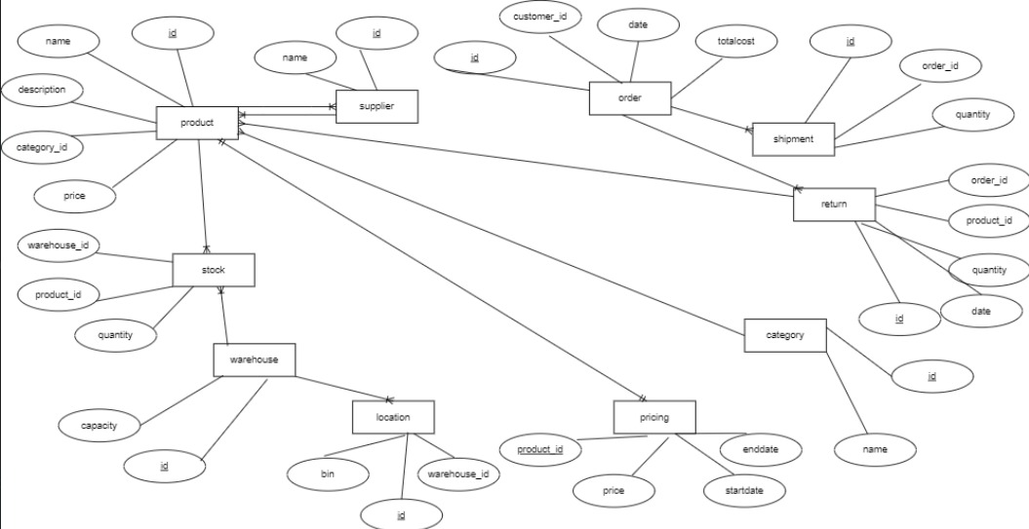

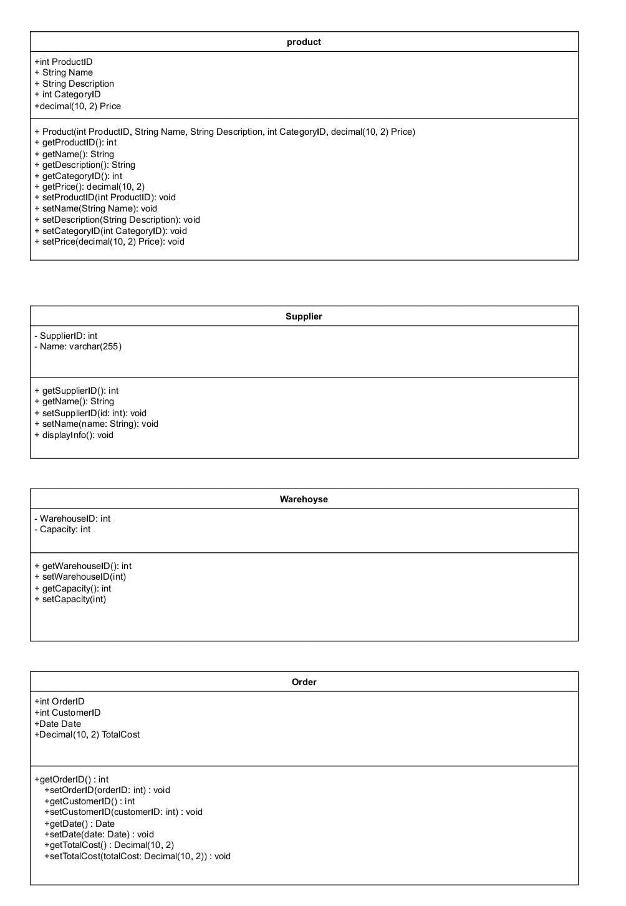

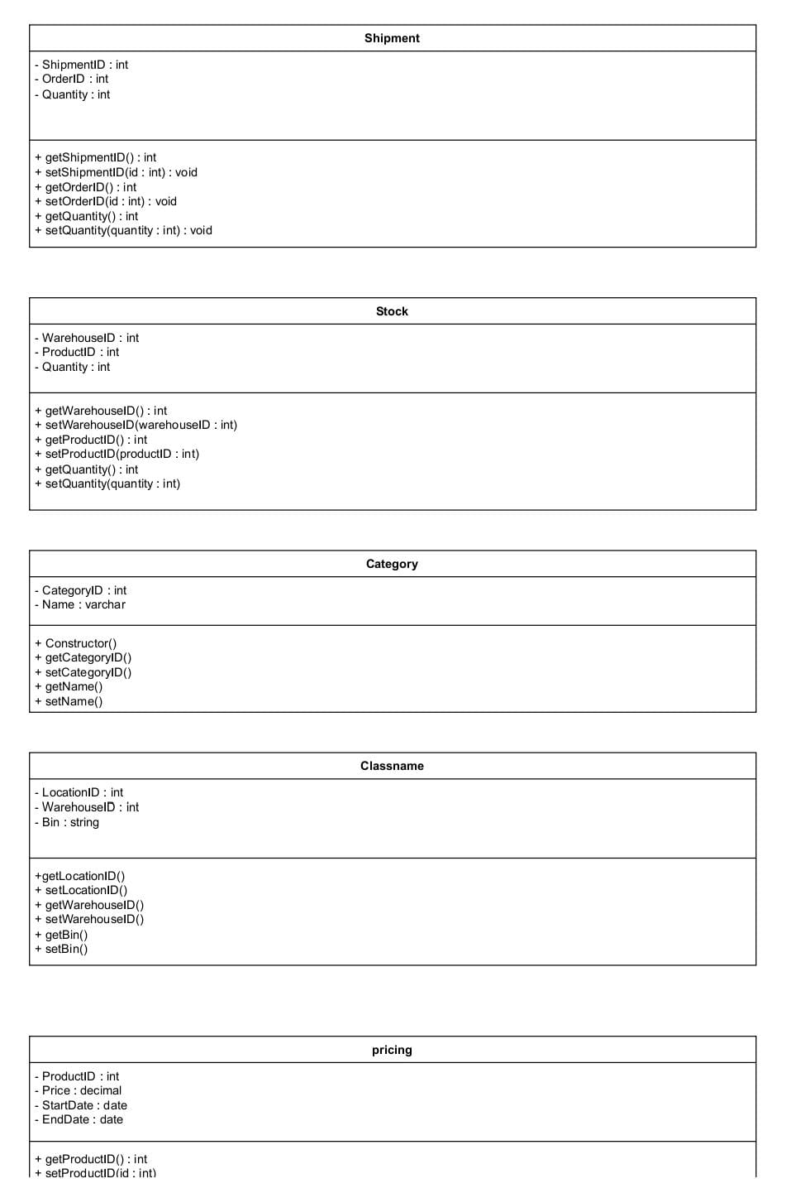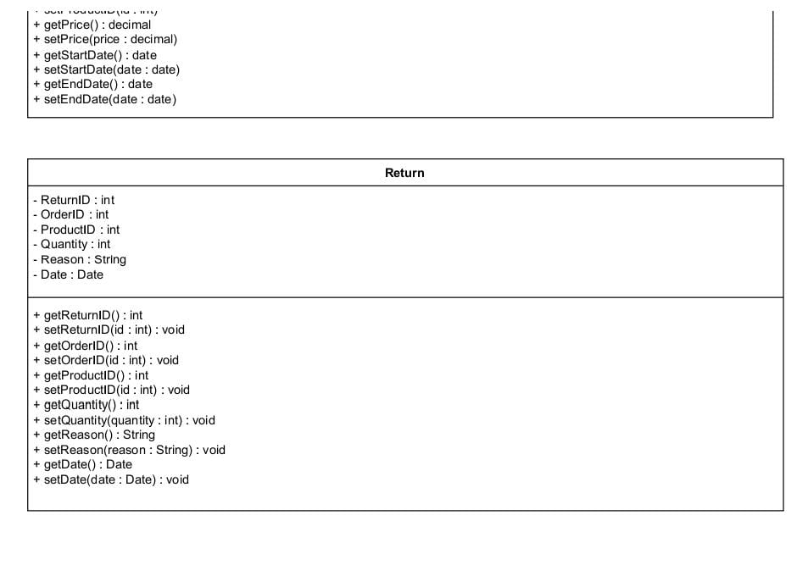

Challenges list:

Creating an inventory management system can be a complex task, and there are several challenges you might encounter along the way. Here's a list of potential challenges you might face when developing or implementing an inventory management system:

* **Data Accuracy**: Maintaining accurate and up-to-date inventory data can be challenging, especially in dynamic environments where inventory levels change frequently.
* **Scalability**: Ensuring that the inventory management system can handle an increasing volume of products and transactions as the business grows.
* **Real-time Visibility**: Providing real-time visibility into inventory levels across multiple locations (warehouses, stores, etc.) can be challenging, especially when dealing with large amounts of data.
* **Inventory Tracking**: Implementing effective tracking mechanisms to monitor inventory movements, including receiving, storage, picking, and shipping, can be challenging, particularly in complex supply chains.
* **Demand Forecasting**: Developing accurate demand forecasting models to predict future inventory needs and optimize stock levels while avoiding stockouts or overstock situations.